OOPS! Ontology Pitfall Assessment and Remediation Report
  - Heart Disease Ontology (HDO) | Protégé / OOPS! Evaluation
This report records the pitfalls identified in the supplied OOPS! assessment screenshots, explains the corrective actions, and distinguishes resolved findings from those requiring further review.

1. Initial evaluation overview
Code | Pitfall | Severity | Initial result
P04 | Creating unconnected ontology elements | Minor | 2 cases
P07 | Merging different concepts in the same class | Minor | 2 cases
P08 | Missing annotations | Minor | 142 cases
P10 | Missing disjointness | Important | Ontology-wide
P13 | Inverse relationships not explicitly declared | Minor | 20 cases
P22 | Using different naming conventions | Minor | Ontology-wide
P31 | Defining wrong equivalent classes | Critical | 4 cases
P41 | No license declared | Important | Ontology-wide

2. Remediation actions for resolved findings

P31 — Defining wrong equivalent classes (Critical; 4 cases)
Identified issue. OOPS! flagged four owl:equivalentClass associations as potentially incorrect. An equivalence axiom asserts that both classes have exactly the same instances; it is therefore stronger than a general relationship or subclass association.
Flagged pairs in the initial report:
- obo:NCIT_C35552 ↔ hdo:CardiovascularSystemFinding
- obo:NCIT_C156818 ↔ hdo:CurrentMedication
- schema:MedicalCondition ↔ fhir:Condition
- schema:Drug ↔ fhir:clinical.medication
Reported outcome: the critical P31 warnings were eliminated in the subsequent evaluation.

P10 — Missing disjointness (Important; ontology-wide)
Identified issue. OOPS! indicated that the ontology lacked explicit disjointness declarations for concepts that should not share instances. Missing disjointness can permit unintended overlaps between concept categories.
Reported outcome: P10 no longer appeared after correction. Missing disjointness was reviewed for relevant class groupings and addressed the missing-disjointness warning in Protégé.

P04 — Creating unconnected ontology elements (Minor; 2 cases)
Identified issue. OOPS! reported two isolated ontology elements lacking suitable links to the surrounding ontology:
- http://purl.obolibrary.org/obo/ncit.owl#C53458
- http://hl7.org/fhir/w5#clinical.diagnostics
Reported outcome: the two P04 cases were removed from the revised findings by adding these classes in domain/ranges of relevant object properties.

P41 — No license declared (Important; ontology-wide)
Identified issue. The original ontology metadata lacked an explicit license declaration, making permissions for reuse and distribution unclear.
Reported outcome: An ontology-level annotation was added under Active Ontology → Annotations in Protégé using dcterms:license with the Creative Commons Attribution 4.0 license URL:
any reused vocabulary licenses.

3. Remaining minor findings and recommended handling
The following findings were present in the initial screenshots. The developer has not reported that all of them were removed, so they should not be described as resolved without a new OOPS! report.
Pitfall | Initial cases | Recommended action
P07 — Merged concepts | 2 | Review DiseaseOrDisorder and schema:MedicalSignOrSymptom. Retain with explicit modelling justification if the grouping is intentional; otherwise separate concepts where queries or reasoning require the distinction.
P08 — Missing annotations | 142 | Add clear rdfs:label and rdfs:comment or definitions to affected locally managed entities; verify the revised count.
P13 — Missing inverse relationships | 20 | Review each suggested object-property inverse. Declare owl:inverseOf only where the inverse meaning is genuinely intended.
P22 — Mixed naming conventions | Ontology-wide | Apply consistent names to HDO-owned entities; retain established IRIs/names of external reused vocabularies where appropriate.

4. Evaluation status and verification

The OntOLogy Pitfall Scanner (OOPS!) was used to test the Heart Disease Ontology (HDO) for potential modelling problems. The first assessment identified critical (P31), important (P10, P41) and minor (P04) pitfalls. These were addressed by removing inappropriate equivalence axioms, adding disjointness axioms, linking isolated ontology elements and adding the CC BY 4.0 license. The remaining minor pitfalls (P07, P08, P13 and P22) were left in place because they were not seen to impact the intended use of the ontology, or its conceptual structure. In total, these enhancements made the ontology structurally, semantically more consistent and of a higher quality.

Appendix A. Original OOPS! evaluation screenshots
The following screenshots document the initial findings prior to the reported corrective actions.
Figure A1. Initial OOPS! results
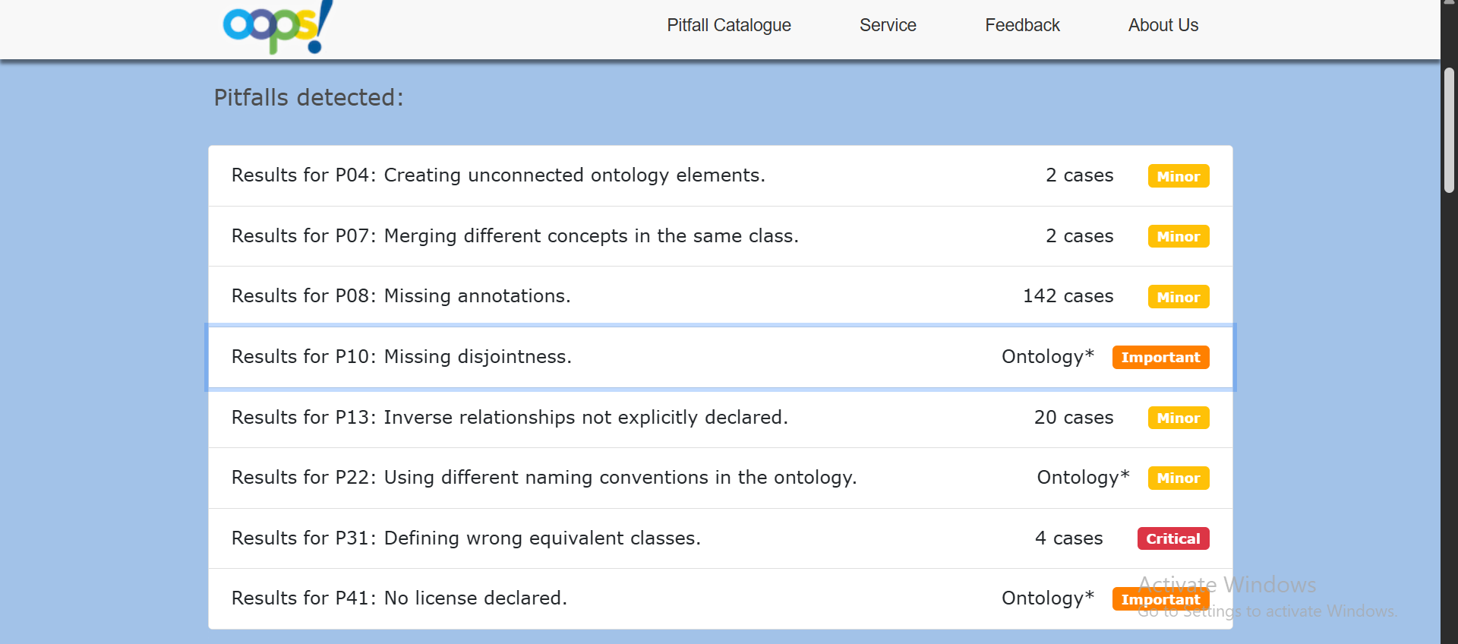

Figure A2. Initial OOPS! results
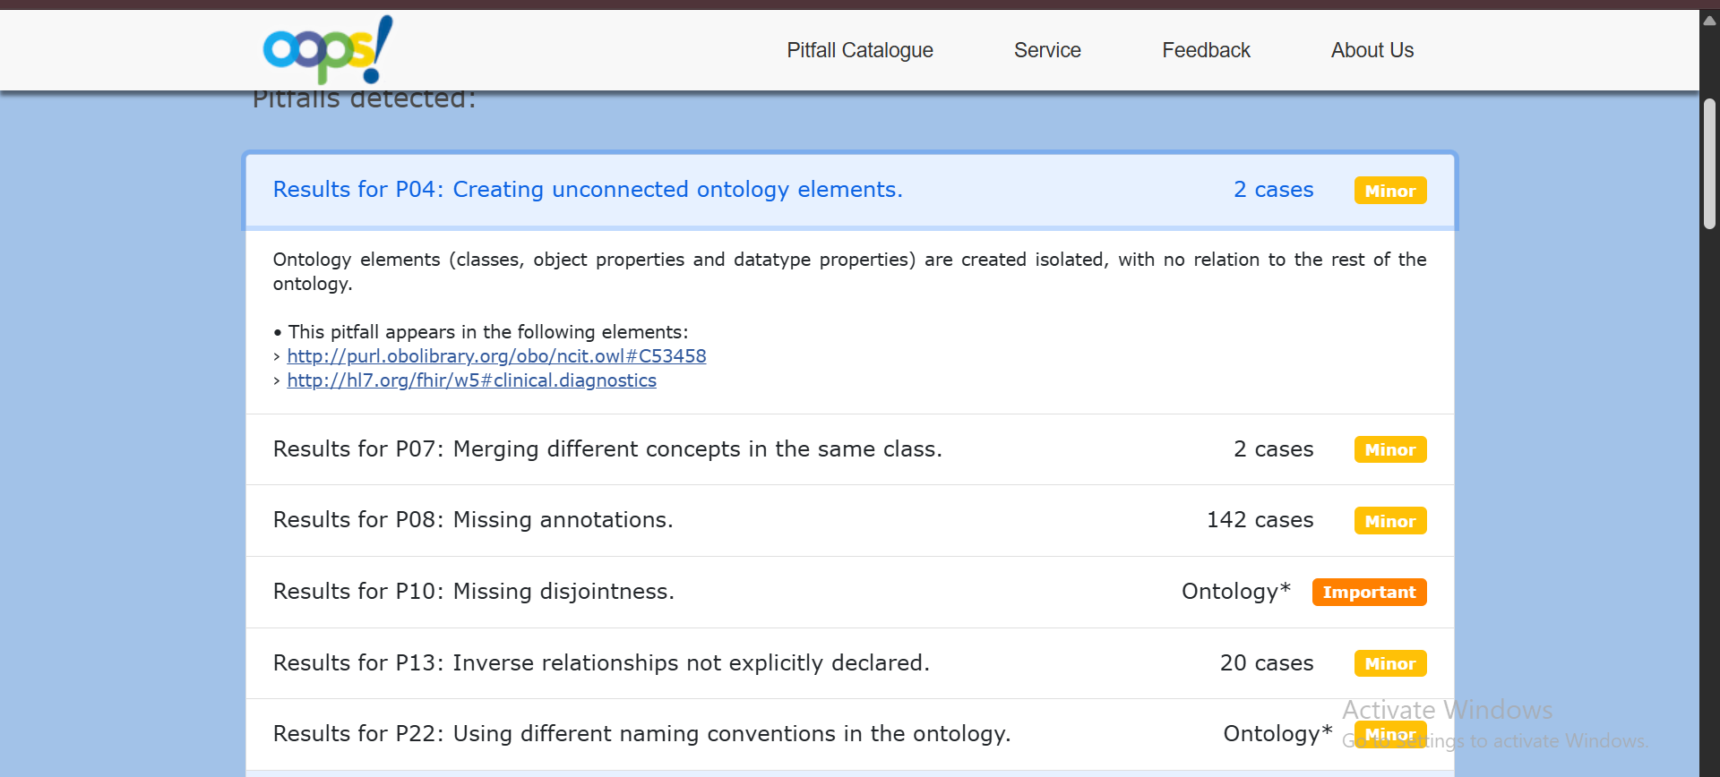

Figure A3. Initial OOPS! results — supplied screenshot 348.
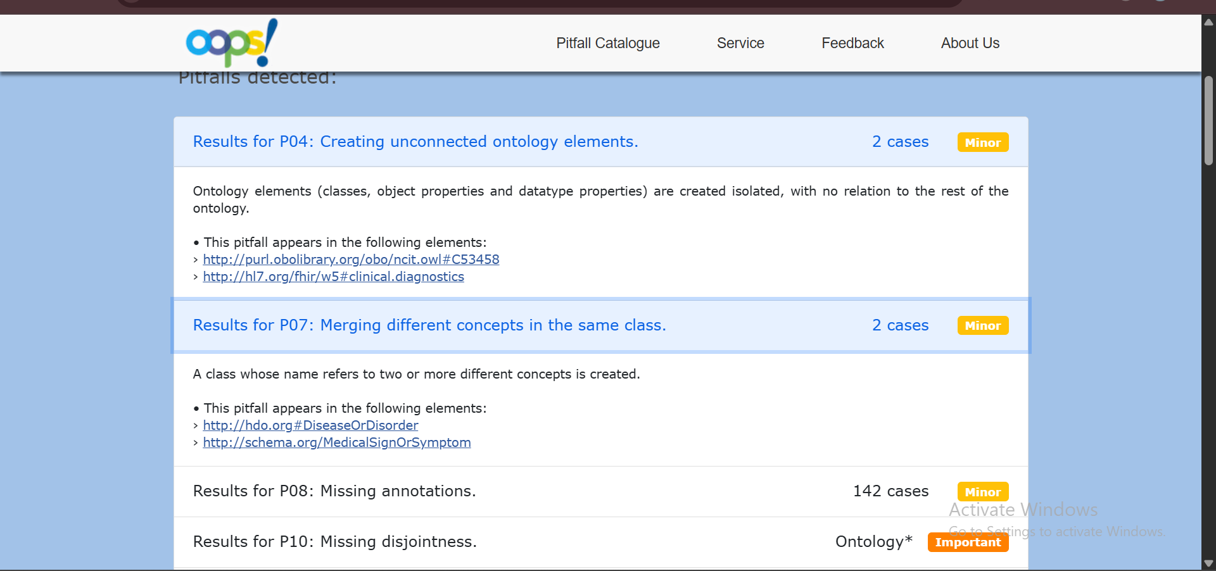

Figure A4. Initial OOPS! results
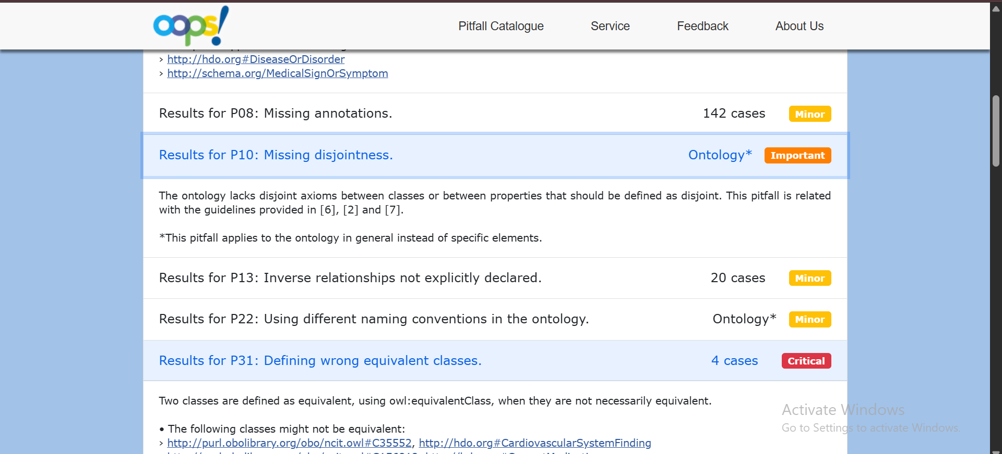

Figure A5. Initial OOPS! results
